《高校新闻》说明文档

目录

**一、 网站说明** **2**

1、 主题 2

2、 文件位置说明 2

**二、 普通用户页面介绍** **2**

1、主页介绍 2

2、内容页介绍 8

3、网站运行结果 11

**三、 管理员增删改查页面介绍** **12**

1、 主页介绍（包括模板） 12

2、插入新闻页面介绍 16

3、更新新闻页面介绍 21

4、删除新闻页面介绍 25

5、编辑新闻页面介绍 25

6、网站运行结果 29

**四、登录注册** **31**

1. 登录界面 31

2. 注册界面 33

3. 其它隐藏登录界面 35

4. 后台登录 38

**五、数据库说明** **40**

1、版本说明 40

2、 数据库表字段及数据说明 41

## 网站说明

### 主题

此网站主题为 高校新闻。

### 文件位置说明

文件夹**Xi'n'W'en**包含

一个images文件夹：主要放置网站所需图片；

一个css文件夹,一个js文件夹,一个jquery文件夹.

一个HouTai文件夹：放置管理员后台页面

一个news数据库脚本文件夹：主要放置数据库脚本文件；还有其他有关网站的asp.net文件；

## **普通用户页面介绍**

一共包含四个页面，分别是主页Default.aspx，子页Default2.aspx，其它子页Default3.aspx和阅读新闻页面readfile.aspx。（MasterPage.master为母版页）

### 1、主页介绍

头部+导航

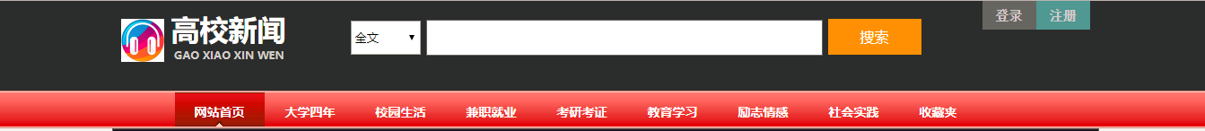

代码分析：

<div class="head">

</div>

<div class="list">

<!--目录-->

<div class="top">

<ul>

<li><a href="Default.aspx" target="_parent" title="网站首页" class="current">网站首页</a></li>

<li><a href="/Default2.aspx" target="_blank" title="大学四年">大学四年</a></li>

<li><a href="# target="_blank" title="校园生活">校园生活</a></li>

<li><a href="#" target="_blank" title="兼职就业">兼职就业</a></li>

<li><a href="#" target="_blank" title="考研考证">考研考证</a></li>

<li><a href="#" target="_blank" title="教育学习">教育学习 </a></li>

<li><a href="#" target="_blank" title="励志情感">励志情感</a></li>

<li><a href="#" target="_blank" title="社会实践">社会实践</a></li>

<li><a href="#" target="_blank" title="收藏夹">收藏夹</a></li>

</ul>

</div>

</div><!--目录end-->

脚部 +学号

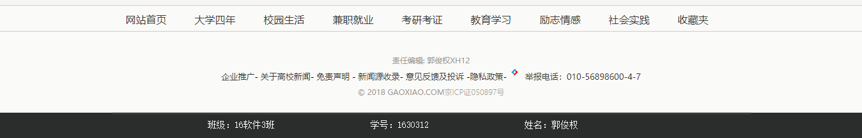

<div class="footer"><!--尾部-->

<div class="top">

<asp:SqlDataSource ID="SqlDataSource1" runat="server" ConnectionString="<%$ ConnectionStrings:newsConnectionString %>" SelectCommand="SELECT [typeid], [typename] FROM [type]"></asp:SqlDataSource>

<asp:DataList ID="DataList1" runat="server" DataKeyField="typeid" DataSourceID="SqlDataSource1" RepeatColumns="9" RepeatDirection="Horizontal">

<ItemTemplate>

<li>

<asp:HyperLink ID="HyperLink1" runat="server" target="_parent" NavigateUrl='<%# "~/Default2.aspx?fileid="+Eval("typeid") %>' Text='<%# Eval("typename") %>'>

</asp:HyperLink>

</li>

</ItemTemplate>

</asp:DataList>

</div>

</div><!--footer end-->

<div class="end">

<p>责任编辑: 郭俊权XH12</p>

<a href="#">企业推广</a>-<a href="#"> 关于高校新闻</a>-<a href="#"> 免责声明 </a>-<a href="#"> 新闻源收录</a>-

<a href="#"> 意见反馈及投诉 </a>-<a href="#">隐私政策</a>-<a href="http://www.12377.cn/" target="_blank">

<img src="images/jubao.png" width="17" height="12" /></a>&nbsp;&nbsp;<span>举报电话：010-56898600-4-7</span>

<p>© 2018 GAOXIAO.COM<a href="http://www.miibeian.gov.cn" target="_blank">京ICP证050897号</a></p>

</div>

内容部=顶部轮播+左侧+右侧+下部图片

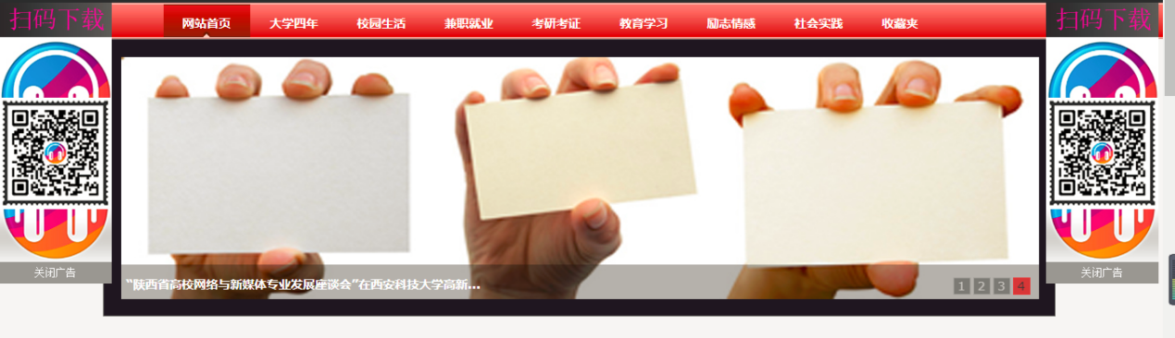

顶部轮播+广告

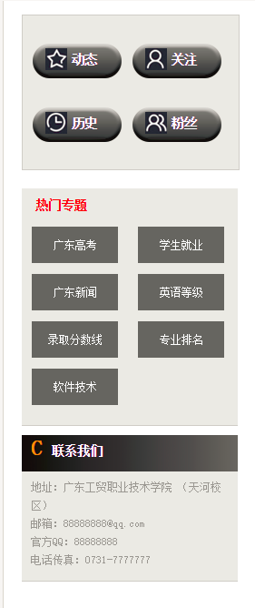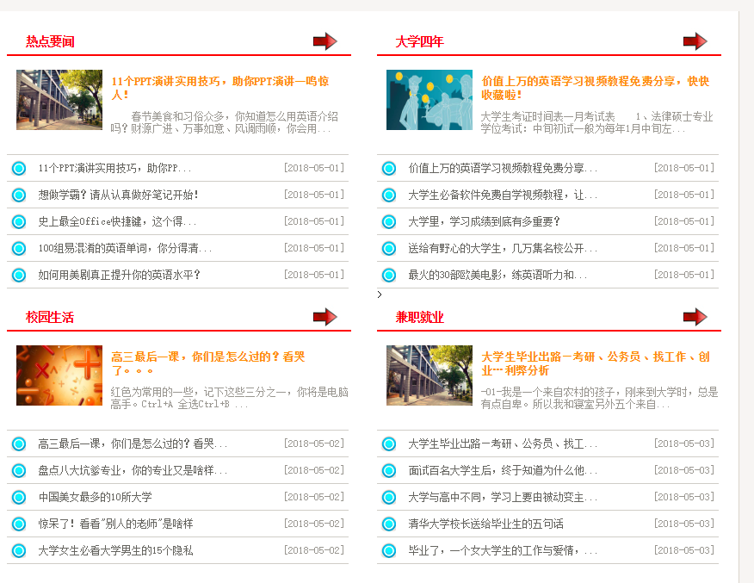

左边热门专题（数据来自数据库） 右边新闻列表（数据来自数据库）+ 新闻列表

左侧部分代码：

<div class="cent_left2">

<asp:Label ID="Label1" runat="server" Text="Label">

<h3>热门专题</h3>

</asp:Label>

<asp:SqlDataSource ID="SqlDataSource5" runat="server" ConnectionString="<%$ ConnectionStrings:newsConnectionString %>"

SelectCommand="SELECT top 8 [keyword] FROM [files] GROUP BY [keyword]"></asp:SqlDataSource>

<asp:DataList ID="DataList1" runat="server" DataSourceID="SqlDataSource5" RepeatColumns="2">

<ItemTemplate>

<li>

<asp:HyperLink ID="HyperLink2" runat="server" NavigateUrl='<%# "~/Default.aspx?fileid="+Eval("keyword") %>' Text='<%# Eval("keyword") %>'></asp:HyperLink>

</li>

</ItemTemplate>

</asp:DataList>

</div>

<!--cent_left2 end-->

右侧部分代码：

<!--cent_cent_top end-->

<div class="cent_cent_img">

<asp:SqlDataSource ID="SqlDataSource6" runat="server" ConnectionString="<%$ ConnectionStrings:newsConnectionString %>"

SelectCommand="SELECT top 1 [fileid], [pic], [filename], [abstract] FROM [files] WHERE ([typeid] = @typeid) ORDER BY [publishdate] DESC, [visitnum] DESC">

<SelectParameters>

<asp:Parameter DefaultValue="1" Name="typeid" Type="Int32" />

</SelectParameters>

</asp:SqlDataSource>

<asp:DataList ID="DataList2" runat="server" DataKeyField="fileid" DataSourceID="SqlDataSource6">

<ItemTemplate>

<div class="cent_img_left">

<asp:Image ID="Image2" runat="server" ImageUrl='<%# Eval("pic") %>' Width="100" Height="70" />

</div>

<!--cent_img_left end-->

<div class="cent_img_right">

<h3>

<asp:HyperLink ID="HyperLink3" runat="server" NavigateUrl='<%# "~/readfile.aspx?fileid="+Eval("fileid") %>' Text='<%# Eval("filename") %>'></asp:HyperLink></h3>

<p>

<asp:Label ID="abstractLabel" runat="server" Text='<%# Eval("abstract").ToString().Length>43 ? Eval("abstract").ToString().Substring(0,42)+"...":Eval("abstract") %>' />

</p>

</div>

<!--cent_img_right end-->

</ItemTemplate>

</asp:DataList>

</div>

<!--cent_cent_top end-->

<div class="cent_cent_left">

<asp:SqlDataSource ID="SqlDataSource1" runat="server" ConnectionString="<%$ ConnectionStrings:newsConnectionString %>"

SelectCommand="SELECT top 5 [fileid], [filename], [publishdate] FROM [files] WHERE ([typeid] = @typeid) ORDER BY [publishdate] DESC, [visitnum] DESC">

<SelectParameters>

<asp:Parameter DefaultValue="1" Name="typeid" Type="Int32" />

</SelectParameters>

</asp:SqlDataSource>

<br />

<asp:GridView ID="GridView1" runat="server" AutoGenerateColumns="False" DataKeyNames="fileid" DataSourceID="SqlDataSource1" GridLines="Horizontal" ShowHeader="False" Width="397px" BackColor="White" BorderColor="#CCCCCC" BorderStyle="None" BorderWidth="1px" CellPadding="4" ForeColor="Black" Style="margin-top: 0px">

<Columns>

<asp:TemplateField>

<ItemTemplate>

<asp:Image ID="Image1" runat="server" ImageUrl="~/images/hd017.png" />

</ItemTemplate>

<ItemStyle Width="25px" />

</asp:TemplateField>

<asp:TemplateField HeaderText="filename" SortExpression="filename">

<EditItemTemplate>

<asp:TextBox ID="TextBox1" runat="server" Text='<%# Bind("filename") %>'></asp:TextBox>

</EditItemTemplate>

<ItemTemplate>

<asp:HyperLink ID="HyperLink1" runat="server" NavigateUrl='<%# "~/readfile.aspx?fileid="+Eval("fileid") %>'

Text='<%# Eval("filename").ToString().Length>18 ? Eval("filename").ToString().Substring(0,17)+"...":Eval("filename") %>' Target="_blank" ToolTip='<%# Eval("filename") %>'>

</asp:HyperLink>

</ItemTemplate>

<ItemStyle Height="22px" />

</asp:TemplateField>

<asp:TemplateField HeaderText="publishdate" SortExpression="publishdate">

<EditItemTemplate>

<asp:TextBox ID="TextBox2" runat="server" Text='<%# Bind("publishdate") %>'></asp:TextBox>

</EditItemTemplate>

<ItemTemplate>

<asp:Label ID="Label2" runat="server" Text='<%#"["+ Eval("publishdate","{0:yyyy-MM-dd}")+"]" %>'></asp:Label>

</ItemTemplate>

<ItemStyle Height="22px" />

</asp:TemplateField>

</Columns>

<FooterStyle BackColor="#CCCC99" ForeColor="Black" />

<HeaderStyle BackColor="#333333" Font-Bold="True" ForeColor="White" />

<PagerStyle BackColor="White" ForeColor="Black" HorizontalAlign="Right" />

<SelectedRowStyle BackColor="#CC3333" Font-Bold="True" ForeColor="White" />

<SortedAscendingCellStyle BackColor="#F7F7F7" />

<SortedAscendingHeaderStyle BackColor="#4B4B4B" />

<SortedDescendingCellStyle BackColor="#E5E5E5" />

<SortedDescendingHeaderStyle BackColor="#242121" />

</asp:GridView>

</div>

<!--cent_cent_left end-->

</div>

<!--cent_cent end-->

底部

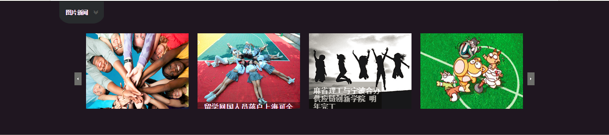

### 2、内容页介绍

与主页不同：主页点击新闻标题跳转到内容页

内容页代码：

<div class="right">

<div class="right_top">

<a href="#" target="_blank" class="a1">最新新闻</a>&nbsp;News

</div>

<div>

<asp:SqlDataSource ID="SqlDataSource1" runat="server" ConnectionString="<%$ ConnectionStrings:newsConnectionString %>" SelectCommand="SELECT [fileid], [filename], [filecontent], [source], [publishdate], [visitnum], [redact] FROM [files] WHERE ([fileid] = @fileid)">

<SelectParameters>

<asp:QueryStringParameter Name="fileid" QueryStringField="fileid" Type="Int32" />

</SelectParameters>

</asp:SqlDataSource>

<asp:DataList ID="DataList1" runat="server" DataKeyField="fileid" DataSourceID="SqlDataSource1">

<ItemTemplate>

<div class="right_cont">

<div class="right_title">

<h1><asp:Label ID="filenameLabel" runat="server" Text='<%# Eval("filename") %>' /></h1>

</div>

<div class="right_cont1">

<h2>

时间：<asp:Label ID="publishdateLabel" runat="server" Text='<%# Eval("publishdate") %>' />&nbsp;&nbsp;

作者：<asp:Label ID="redactLabel" runat="server" Text='<%# Eval("redact") %>' />&nbsp;&nbsp;

来源：<a href="#"><asp:Label ID="sourceLabel" runat="server" Text='<%# Eval("source") %>' /></a>

</h2>

</div><!--right_cont1 end-->

<div class="right_cont2">

<asp:Label ID="filecontentLabel" runat="server" Text='<%# Eval("filecontent") %>' />

</div><!--right_cont2 end-->

</ItemTemplate>

</asp:DataList>

</div>

</div>

<!--right end-->

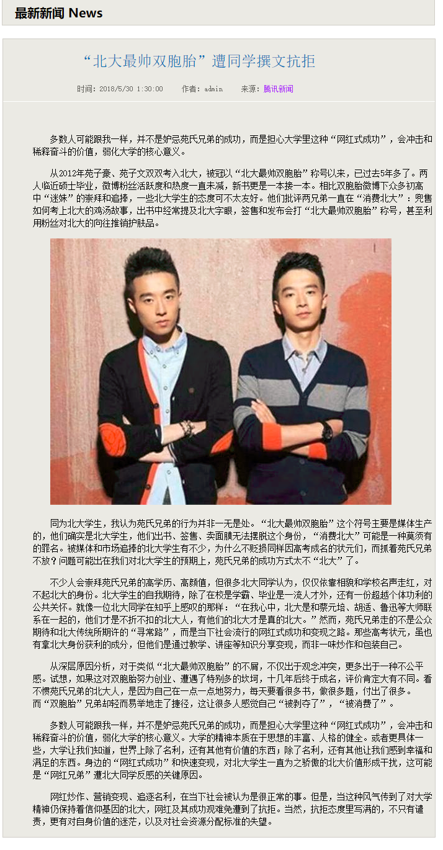

通过主页传过来的newsID号来获取数据库对应的新闻标题内容。

### 3、网站运行结果

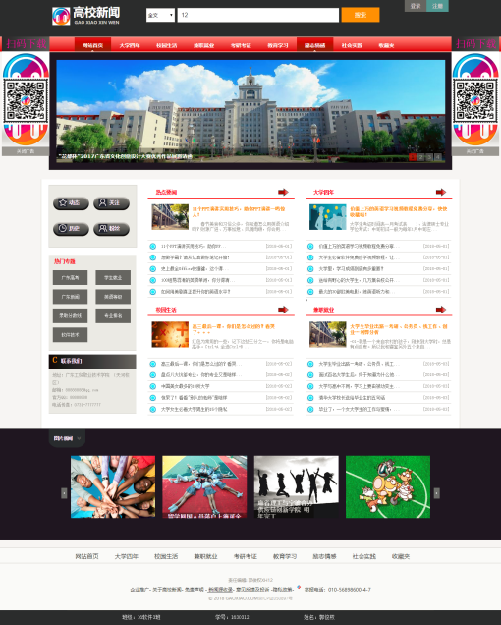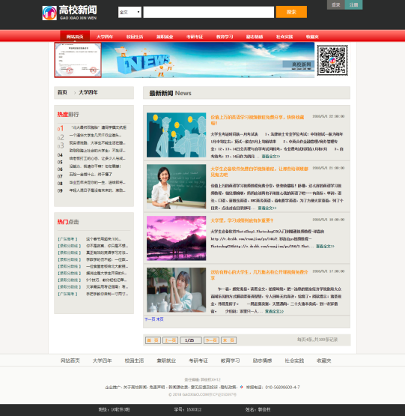

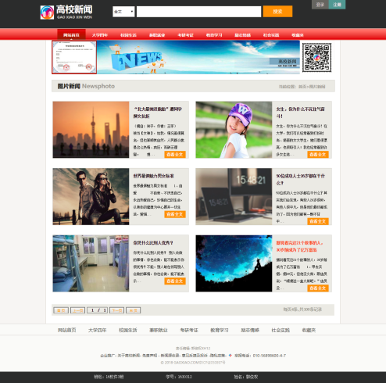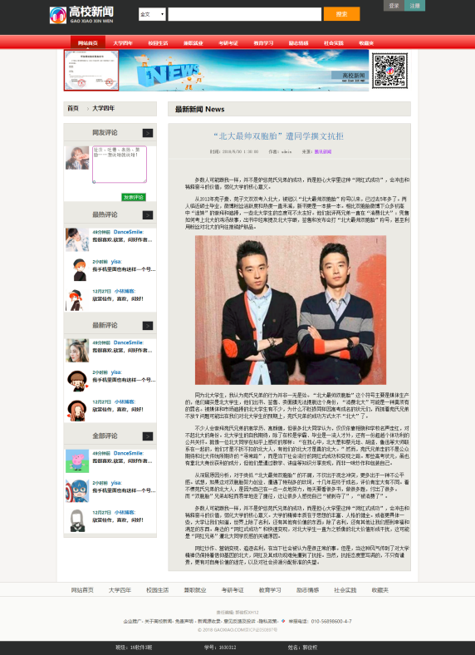

## **管理员增删改查页面介绍**

一共包含主要四个页面，分别是主页和有关的增删改查页面包括模板。

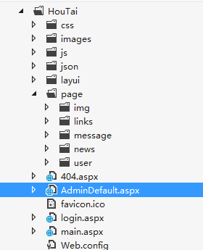

### 主页介绍（包括模板）

AdminDefault.aspx

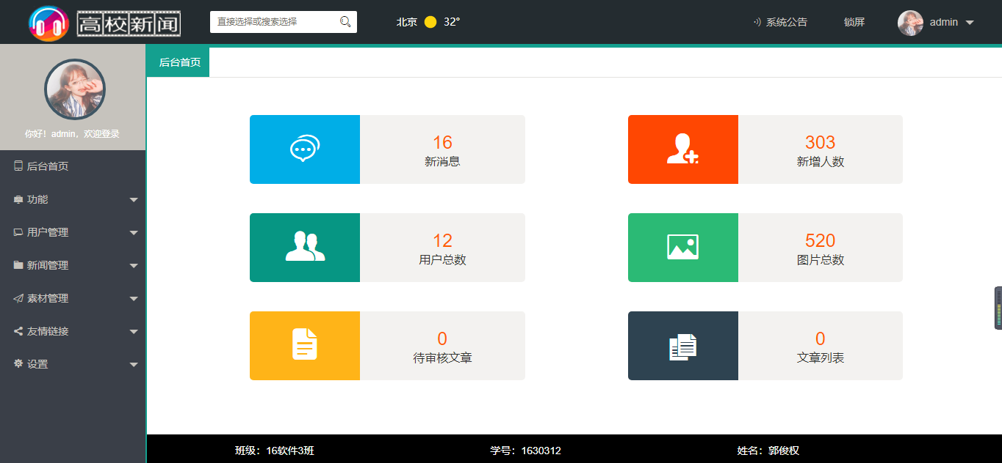

代码实现

模板：

<%@ Page Language="C#" AutoEventWireup="true" CodeFile="AdminDefault.aspx.cs" Inherits="_Default" %>

<!DOCTYPE html>

<html xmlns="http://www.w3.org/1999/xhtml">

<head runat="server">

<meta http-equiv="Content-Type" content="text/html; charset=utf-8" />

<title>高校新闻后台</title>

<link rel="icon" href="favicon.ico"/>

<link href="layui/css/layui.css" rel="stylesheet" />

<link href="css/main.css" rel="stylesheet" />

</head>

<body class="main_body">

<form id="form1" runat="server">

<div class="layui-layout layui-layout-admin">

<!-- 顶部 -->

<div class="layui-header header">

<div class="layui-main">

<a href="#" class="logo"><img src="images/logo.png" /></a>

<!-- 搜索 -->

<div class="layui-form component">

<select name="modules" lay-verify="required" lay-search="">

<option value="">直接选择或搜索选择</option>

<option value="1">群发功能</option>

<option value="2">自动回复</option>

<option value="3">用户管理</option>

<option value="4">新闻列表</option>

<option value="5">增加新闻</option>

<option value="6">图片</option>

<option value="7">友情链接</option>

<option value="8">设置</option>

<option value="9">flow</option>

</select>

<i class="layui-icon">&#xe615;</i>

</div>

<!-- 天气信息 -->

<div class="weather">

<div id="tp-weather-widget"></div>

<script>(function (T, h, i, n, k, P, a, g, e) { g = function () { P = h.createElement(i); a = h.getElementsByTagName(i)[0]; P.src = k; P.charset = "utf-8"; P.async = 1; a.parentNode.insertBefore(P, a) }; T["ThinkPageWeatherWidgetObject"] = n; T[n] || (T[n] = function () { (T[n].q = T[n].q || []).push(arguments) }); T[n].l = +new Date(); if (T.attachEvent) { T.attachEvent("onload", g) } else { T.addEventListener("load", g, false) } }(window, document, "script", "tpwidget", "//widget.seniverse.com/widget/chameleon.js"))</script>

<script>tpwidget("init", {

"flavor": "slim",

"location": "WX4FBXXFKE4F",

"geolocation": "disabled",

"language": "zh-chs",

"unit": "c",

"theme": "chameleon",

"container": "tp-weather-widget",

"bubble": "disabled",

"alarmType": "badge",

"color": "#FFFFFF",

"uid": "U9EC08A15F",

"hash": "14dff75e7253d3a8b9727522759f3455"

});

tpwidget("show");</script>

</div>

<!-- 顶部右侧菜单 -->

<ul class="layui-nav top_menu">

<li class="layui-nav-item showNotice" id="showNotice">

<a href="javascript:;"><i class="layui-icon">&#xe688;</i><cite>系统公告</cite></a>

</li>

<li class="layui-nav-item lockcms">

<a href="javascript:;"><i class="layui-icon"></i><cite>锁屏</cite></a>

</li>

<li class="layui-nav-item">

<a href="javascript:;">

<asp:Image ID="picture" runat="server" class="layui-circle" width="35" height="35"/>

<cite><asp:Label ID="managename1" runat="server" Text = "未登录"></asp:Label></cite>

</a>

<dl class="layui-nav-child">

<dd><a href="javascript:;" data-url="page/user/userInfo.aspx"><i class="layui-icon " data-icon="&#xe60a;">&#xe60a;</i><cite>编辑资料</cite></a></dd>

<dd><a href="javascript:;" data-url="page/user/changePwd.aspx"><i class="layui-icon " data-icon="&#xe642;">&#xe63c;</i><cite>修改密码</cite></a></dd>

<dd><a href="login.aspx" data-url="login.aspx" target="_parent"><i class="layui-icon " data-icon="&#xe643;">&#xe643;</i><cite>退出</cite></a></dd>

</dl>

</li>

</ul>

</div>

</div>

<!-- 左侧导航 -->

<div class="layui-side layui-bg-black">

<div class="user-photo">

<a class="img" title="我的头像"><asp:Image ID="picture1" runat="server" /></a>

<p><asp:Label ID="lblloginmessage" runat="server" Text = "请退出后管理员登录！！！"></asp:Label></p>

</div>

<div class="navBar layui-side-scroll"></div>

</div>

<!-- 右侧内容 -->

<div class="layui-body layui-form">

<div class="layui-tab marg0" lay-filter="bodyTab">

<ul class="layui-tab-title top_tab">

<li class="layui-this" lay-id=""><i class="iconfont"></i><cite>后台首页</cite></li>

</ul>

<div class="layui-tab-content clildFrame">

<div class="layui-tab-item layui-show">

<iframe src="main.aspx"></iframe>

</div>

</div>

</div>

</div>

<!-- 底部 -->

<div class="layui-footer footer">

<div class="bottom">

<ul>

<li>班级：16软件3班</li>

<li>学号：1630312</li>

<li>姓名：郭俊权</li>

</ul>

</div>

</div>

</div>

<!-- 锁屏 -->

<div class="admin-header-lock" id="lock-box" style="display: none;">

<div class="admin-header-lock-img"><asp:Image ID="picture2" runat="server" /></div>

<div class="admin-header-lock-name" id="lockUserName"><asp:Label ID="managename2" runat="server" Text = "未登录状态"></asp:Label></div>

<div class="input_btn">

<input type="password" class="admin-header-lock-input layui-input" placeholder="请输入密码解锁.." name="lockPwd" id="lockPwd" />

<button class="layui-btn" id="unlock">解锁</button>

</div>

<p>

<asp:Label ID="hint1" runat="server" Text="请输入“123456”，否则不会解锁成功哦！！！"></asp:Label></p>

</div>

<script type="text/javascript" src="layui/layui.js"></script>

<script type="text/javascript" src="js/nav.js"></script>

<script type="text/javascript" src="js/leftNav.js"></script>

<script type="text/javascript" src="js/index.js"></script>

</form>

</body>

</html>

### 2、插入新闻页面介绍

newsAdd.aspx



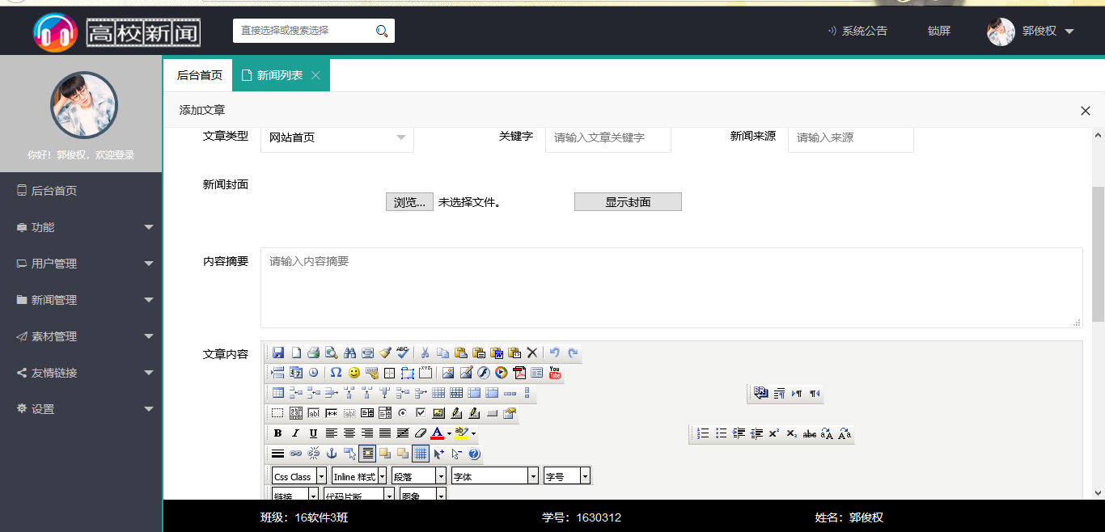

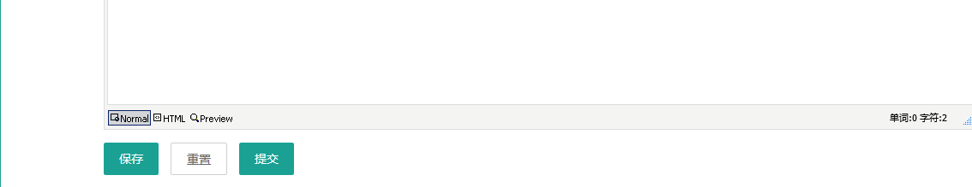

代码实现

using System;

using System.Collections.Generic;

using System.Linq;

using System.Web;

using System.Web.UI;

using System.Web.UI.WebControls;

using System.Data;

using System.Data.SqlClient;

using System.Configuration;

public partial class page_news_newsAdd : System.Web.UI.Page

{

public static String conString = ConfigurationManager.ConnectionStrings["newsConnectionString"].ToString();

private SqlConnection con = new SqlConnection(conString);

protected void Page_Load(object sender, EventArgs e)

{

if (Request.QueryString["fileid"] != null)

{

ShowMessage(int.Parse(Request.QueryString["fileid"]));

}

}

protected void Button1_Click(object sender, EventArgs e)

{

}

protected void Button3_Click(object sender, EventArgs e)

{

//Label9.Text = TextBox1.Text + " " + TextBox2.Text + " " + TextBox3.Text + " " + TextBox4.Text + " " + TextBox5.Text + " " + TextBox6.Text + " " + drpfiletype.SelectedValue;

//Label9.Text = "haha";

if (TextBox1.Text == "")

{

Response.Write("<script>alert('文章标题不能为空！！！')</script>");

}

else if (Label11.Text.Trim() != "文件上传成功!预约如图所示：")

{

Response.Write("<script>alert('请上传封面图片！！！')</script>");

}

else if (TextBox2.Text == "")

{

Response.Write("<script>alert('文章作者不能为空！！！')</script>");

}

else if (TextBox3.Text == "")

{

Response.Write("<script>alert('发布时间不能为空！！！')</script>");

}

else if (TextBox4.Text == "")

{

Response.Write("<script>alert('关键字不能为空！！！')</script>");

}

else if (TextBox8.Text == "")

{

Response.Write("<script>alert('新闻来源不能为空！！！')</script>");

}

else if (TextBox5.Text == "")

{

Response.Write("<script>alert('内容摘要不能为空！！！')</script>");

}

else if (Editor1.Text.Trim() == "")

{

Response.Write("<script>alert('文章内容不能为空！！！')</script>");

}

else

{

String sql = "insert into files(filename,publishdate,redact,keyword,abstract,filecontent,typeid,source,pic) values('" + TextBox1.Text + "','" + TextBox3.Text + "','" + TextBox2.Text + "','" + TextBox4.Text + "','" + TextBox5.Text + "','" + Editor1.Text + "'," + int.Parse(drpfiletype.SelectedValue) + ",'"+TextBox8.Text+"','"+Label12.Text+ "')";

try

{

con.Open();

SqlCommand com = new SqlCommand(sql, con);

if (com.ExecuteNonQuery() <= 0)

Response.Write("<script>alert('发布失败')</script>");

else

Response.Write("<script>alert('发布成功')</script>");

}

catch (Exception ex)

{

Response.Write("<script>alert('发布失败1')</script>");

}

finally

{

con.Close();

}

}

}

protected void Button4_Click(object sender, EventArgs e)

{

bool files = false;

if (this.FileUpload1.HasFile)

{

//获取上传文件的后缀

String fileExtension = System.IO.Path.GetExtension(this.FileUpload1.FileName).ToLower();

String[] restrictExtension = { ".gif", ".jpg", ".bmp", ".png" };

//判断文件类型是否符合

for (int i = 0; i < restrictExtension.Length; i++)

{

if (fileExtension == restrictExtension[1])

{

files = true;

}

}

//调用SaveAs方法实现上传

if (files == true)

{

try

{

this.Image1.ImageUrl = "~/images/" + FileUpload1.FileName;

this.FileUpload1.SaveAs(Server.MapPath("~/images/") + FileUpload1.FileName);

this.Label11.Text = "文件上传成功!预约如图所示：";

Label12.Text = "~/images/" + FileUpload1.FileName;

}

catch

{

this.Label11.Text = "文件上传不成功";

}

}

else

{

this.Label11.Text = "只能够上传后缀为.gif、 .jpg、 .bmp、.png的文件夹";

}

}

}

public void ShowMessage(int fileid)

{

String sql = "select * from files where fileid = " + fileid;

con.Open();

SqlCommand com = new SqlCommand(sql, con);

SqlDataReader re = com.ExecuteReader();

try

{

if (re.Read())

{

TextBox1.Text = re.GetString(1);

TextBox2.Text = re.GetString(7);

TextBox3.Text = re.GetDateTime(5).ToShortDateString();

TextBox4.Text = re.GetString(10);

TextBox5.Text = re.GetString(8);

Editor1.Text = re.GetString(3);

}

}

catch (Exception ex)

{

Response.Write("<script>alert('error')</script>");

}

finally

{

con.Close();

}

}

}

### 3、更新新闻页面介绍

newsList.aspx

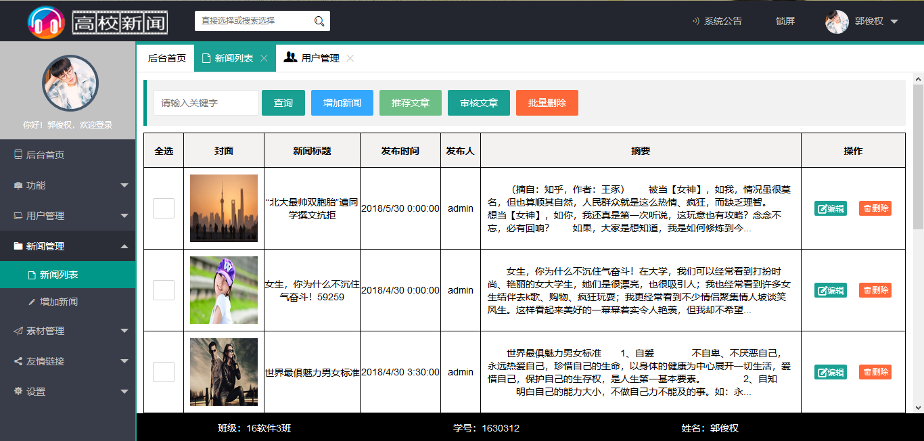

代码实现

using System;

using System.Collections.Generic;

using System.Linq;

using System.Web;

using System.Web.UI;

using System.Web.UI.WebControls;

using System.Data;

using System.Data.SqlClient;

using System.Collections;

using System.Configuration;

public partial class page_news_newsList : System.Web.UI.Page

{

public static String conString = ConfigurationManager.ConnectionStrings["newsConnectionString"].ToString();

private SqlConnection con = new SqlConnection(conString);

ArrayList deleteFile = new ArrayList();

protected void Page_Load(object sender, EventArgs e)

{

}

protected void GridView1_RowDeleted(object sender, GridViewDeletedEventArgs e)

{

GridView1.DataBind();

}

protected void GridView1_RowDeleting(object sender, GridViewDeleteEventArgs e)

{

DataKey key = GridView1.DataKeys[e.RowIndex];

int id = int.Parse(key[0].ToString());

if (HasPinglun(id))

{

e.Cancel = true;

Response.Write("<script>alert('请先删除评论')</script>");

}

initCheckBox();

}

//判断新闻是否有评论

public Boolean HasPinglun(int id)

{

String sql = "select * from pinglun where fileid = " + id;

con.Open();

try

{

SqlCommand com = new SqlCommand(sql, con);

SqlDataReader re = com.ExecuteReader();

if (re.HasRows)

{

re.Close();

return true;

}

re.Close();

return false;

}

catch (Exception ex)

{

return false;

}

finally

{

con.Close();

}

}

//删除对应id的新闻

public void DeleteFile(int id)

{

String sql = "delete from files where fileid = " + id;

con.Open();

try

{

SqlCommand com = new SqlCommand(sql, con);

if (com.ExecuteNonQuery() <= 0)

Response.Write("<script>alert('新闻" + id + "删除失败')</script>");

}

catch (Exception ex)

{

Response.Write("<script>alert('新闻" + id + "删除失败')</script>");

}

finally

{

con.Close();

}

}

//重置选中按钮

public void initCheckBox()

{

foreach (CheckBox b in deleteFile)

b.Checked = false;

deleteFile.Clear();

}

protected void CheckBox1_CheckedChanged(object sender, EventArgs e)

{

CheckBox b = (CheckBox)sender;

if (b.Checked)

deleteFile.Add(b);

else

{

if (deleteFile.Contains(b))

deleteFile.Remove(b);

}

}

protected void Button5_Click(object sender, EventArgs e)

{

ArrayList cancel = new ArrayList();

Button bt = (Button)sender;

if (deleteFile.Count == 0)

Response.Write("<script>alert('请选择你要删除的行')</script>");

else

{

foreach (CheckBox b in deleteFile)

{

int id = int.Parse(b.ToolTip);

if (HasPinglun(id))

{

cancel.Add(id);

}

else

{

DeleteFile(id);

}

}

if (cancel.Count == 0)

Response.Write("<script>alert('删除成功')</script>");

else

{

String s = "";

foreach (int i in cancel)

{

s += i + ",";

}

Response.Write("<script>alert('新闻" + s.Substring(0, s.Length - 1) + "删除失败,原因:有评论没有删除')</script>");

}

}

initCheckBox();

GridView1.DataBind();

}

protected void GridView1_PageIndexChanged(object sender, EventArgs e)

{

initCheckBox();

}

protected void LinkButton1_Click(object sender, EventArgs e)

{

LinkButton bt = (LinkButton)sender;

Response.Redirect("newsEdit.aspx?fileid=" + bt.ToolTip);

}

protected void LinkButton2_Click(object sender, EventArgs e)

{

}

}

### 4、删除新闻页面介绍

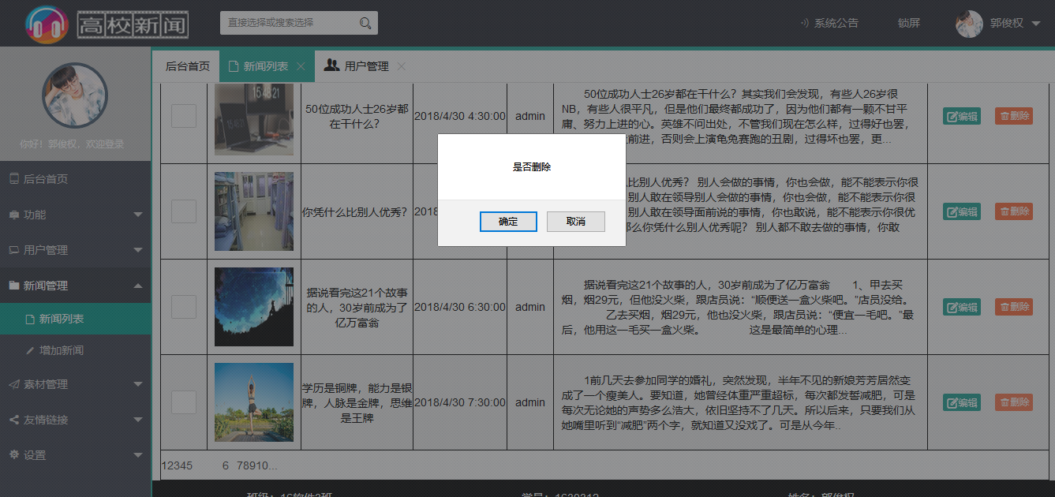

### 5、编辑新闻页面介绍

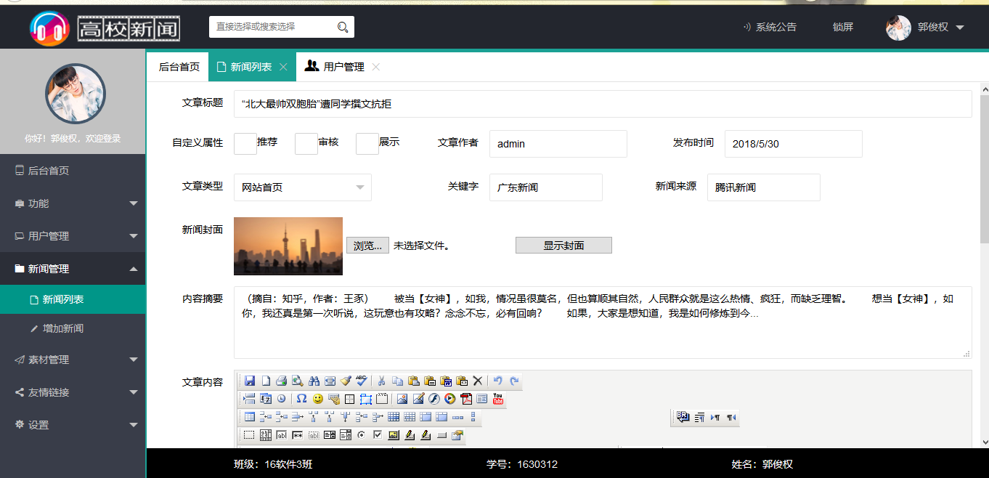

using System;

using System.Collections.Generic;

using System.Linq;

using System.Web;

using System.Web.UI;

using System.Web.UI.WebControls;

using System.Data;

using System.Data.SqlClient;

using System.Configuration;

public partial class HouTai_page_news_newsEdit : System.Web.UI.Page

{

public static String conString = ConfigurationManager.ConnectionStrings["newsConnectionString"].ToString();

private SqlConnection con = new SqlConnection(conString);

protected void Page_Load(object sender, EventArgs e)

{

if(!Page.IsPostBack)

if (Request.QueryString["fileid"] != null)

{

ShowMessage(int.Parse(Request.QueryString["fileid"]));

}

}

public void ShowMessage(int fileid)

{

String sql = "select * from files where fileid = " + fileid;

con.Open();

SqlCommand com = new SqlCommand(sql, con);

SqlDataReader re = com.ExecuteReader();

try

{

if (re.Read())

{

TextBox1.Text = re.GetString(1);

TextBox2.Text = re.GetString(7);

TextBox3.Text = re.GetDateTime(5).ToShortDateString();

TextBox4.Text = re.GetString(9);

TextBox5.Text = re.GetString(8);

Editor1.Text = re.GetString(3);

TextBox8.Text = re.GetString(4);

Image1.ImageUrl = re.GetString(10);

}

}

catch (Exception ex)

{

Response.Write("<script>alert('error')</script>");

}

finally

{

con.Close();

}

}

protected void Button4_Click(object sender, EventArgs e)

{ bool files = false;

if (this.FileUpload1.HasFile)

{

//获取上传文件的后缀

String fileExtension = System.IO.Path.GetExtension(this.FileUpload1.FileName).ToLower();

String[] restrictExtension = { ".gif", ".jpg", ".bmp", ".png" };

//判断文件类型是否符合

for (int i = 0; i < restrictExtension.Length; i++)

{

if (fileExtension == restrictExtension[1])

{

files = true;

}

}

//调用SaveAs方法实现上传

if (files == true)

{

try

{

this.Image1.ImageUrl = "~/images/" + FileUpload1.FileName;

this.FileUpload1.SaveAs(Server.MapPath("~/images/") + FileUpload1.FileName);

this.Label11.Text = "文件上传成功!预约如图所示：";

}

catch

{

this.Label11.Text = "文件上传不成功";

}

}

else

{

this.Label11.Text = "只能够上传后缀为.gif、 .jpg、 .bmp、.png的文件夹";

}

}

}

protected void Button3_Click(object sender, EventArgs e)

{

//Label9.Text = TextBox1.Text + " " + TextBox2.Text + " " + TextBox3.Text + " " + TextBox4.Text + " " + TextBox5.Text + " " + TextBox6.Text + " " + drpfiletype.SelectedValue;

//Label9.Text = "haha";

if (TextBox1.Text == "")

{

Response.Write("<script>alert('文章标题不能为空！！！')</script>");

}

else if (TextBox2.Text == "")

{

Response.Write("<script>alert('文章作者不能为空！！！')</script>");

}

else if (TextBox3.Text == "")

{

Response.Write("<script>alert('发布时间不能为空！！！')</script>");

}

else if (TextBox4.Text == "")

{

Response.Write("<script>alert('关键字不能为空！！！')</script>");

}

else if (TextBox8.Text == "")

{

Response.Write("<script>alert('新闻来源不能为空！！！')</script>");

}

else if (TextBox5.Text == "")

{

Response.Write("<script>alert('内容摘要不能为空！！！')</script>");

}

else if (Editor1.Text.Trim() == "")

{

Response.Write("<script>alert('文章内容不能为空！！！')</script>");

}

else

{

String sql = "update files set filename = '" + TextBox1.Text + "',publishdate ='" + TextBox3.Text + "',redact='" + TextBox2.Text + "',keyword='" + TextBox4.Text + "',abstract='" + TextBox5.Text + "',filecontent= '" + Editor1.Text + "',typeid=" + int.Parse(drpfiletype.SelectedValue) + ",source='" + TextBox8.Text + "',pic='" + Image1.ImageUrl + "' where fileid = " + int.Parse(Request.QueryString["fileid"]);

try{

con.Open();

SqlCommand com = new SqlCommand(sql, con);

if (com.ExecuteNonQuery() <= 0)

Response.Write("<script>alert('保存失败')</script>");

else

Response.Write("<script>alert('保存成功')</script>");

}

catch (Exception ex)

{

Response.Write("<script>alert('保存失败')</script>");

}

finally

{

con.Close();

}

}

}

}

### 6、网站运行结果

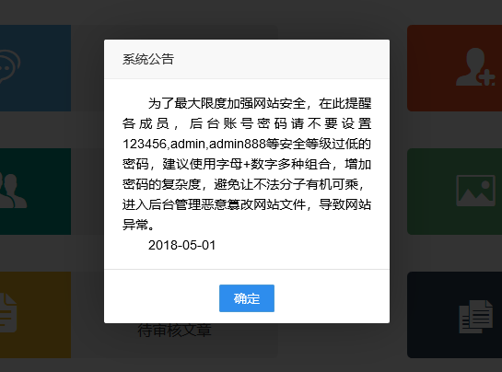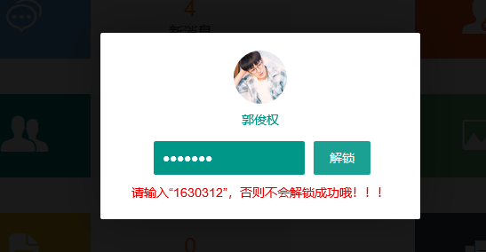

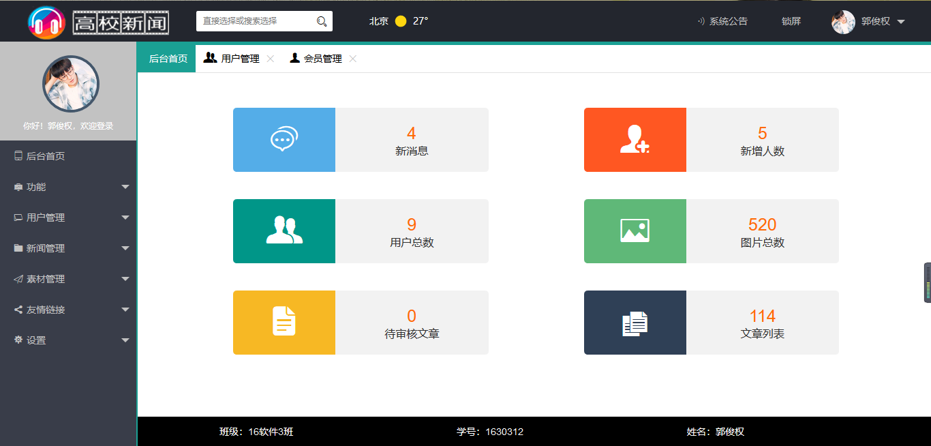

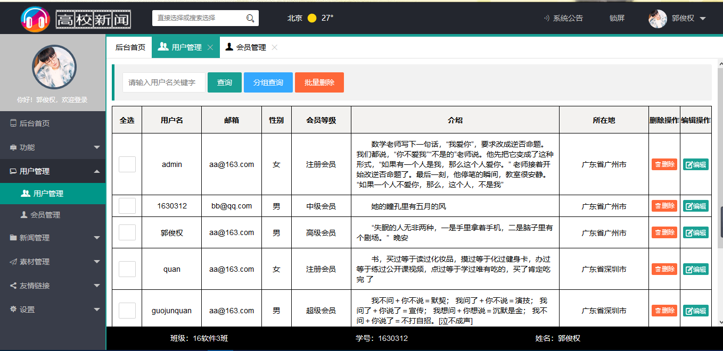

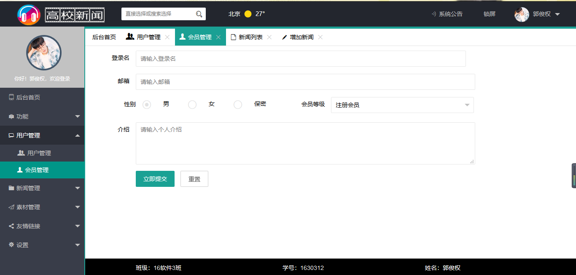

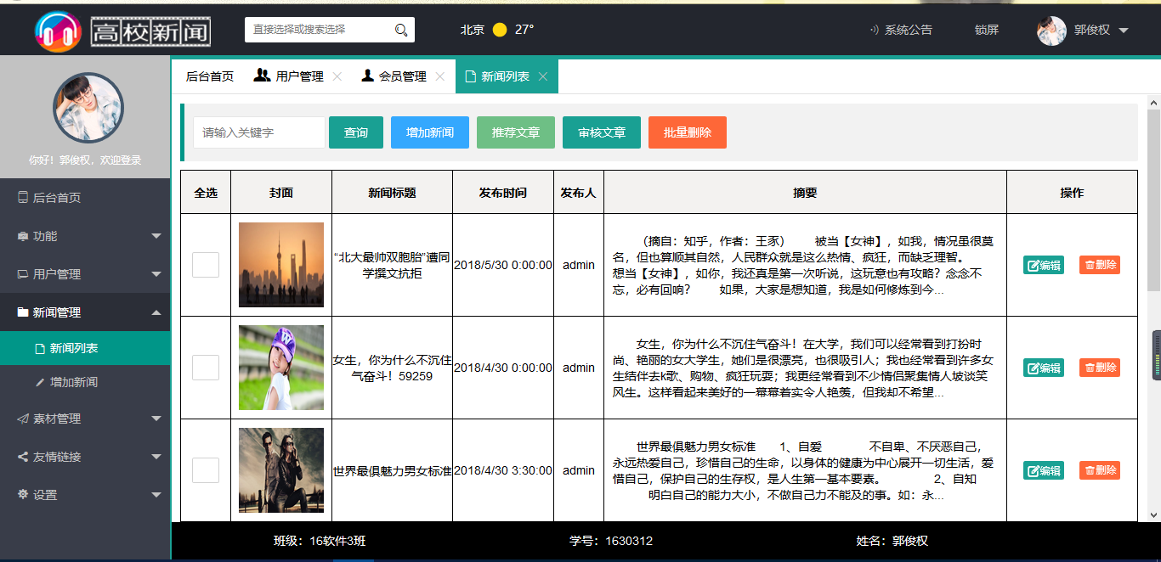

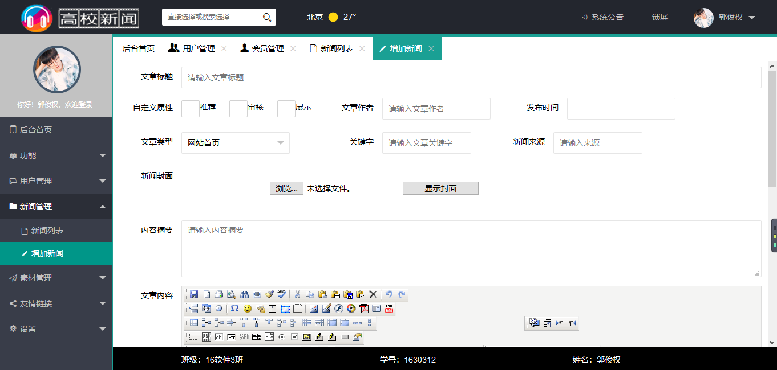

## 四、登录注册

### 登录界面

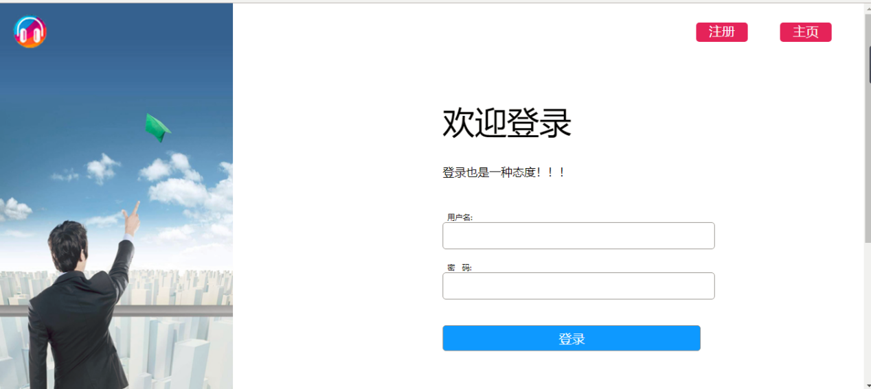

代码：

using System;

using System.Collections.Generic;

using System.Linq;

using System.Web;

using System.Web.UI;

using System.Web.UI.WebControls;

using System.Data;

using System.Data.SqlClient;

using System.Configuration;

public partial class login : System.Web.UI.Page

{

//获取配置连接信息

public static string connstr = ConfigurationManager.ConnectionStrings["newsConnectionString"].ConnectionString;

//建立连接对象 ，将配置信息作为 连接对象的参数

SqlConnection conn = new SqlConnection(connstr);

protected void Page_Load(object sender, EventArgs e)

{

}

protected void btnlogin_Click(object sender, EventArgs e)

{

try

{

//写对数据库的操作语句

string str = "select * from users where username='" + txtmanagename.Text + "' and password='" + txtmanagepassword.Text + "'";

//打开数据库连接；

conn.Open();

//建立一个对数据库的操作的执行对象命令

SqlCommand cmd = new SqlCommand(str, conn);

//执行对数据库的操作，并将对数据库操作的结果保存起来

SqlDataReader reader = cmd.ExecuteReader();

//对结果进行判断并处理

if (reader.HasRows)

{

Session["username"] = txtmanagename.Text;

Session["password"] = txtmanagepassword.Text;

// Response.Write("<script>alert('登录成功!')</script>");

Response.Redirect("Default.aspx");

}

else

Response.Write("<script>alert('用户名或密码错误，登录不成功')</script>");

reader.Close();

}

catch

{

Response.Write("<script>alert('用户名或密码错误，登录失败')</script>");

}

//关闭数据集，关闭连接

finally

{

conn.Close();

}

}

}

### 注册界面

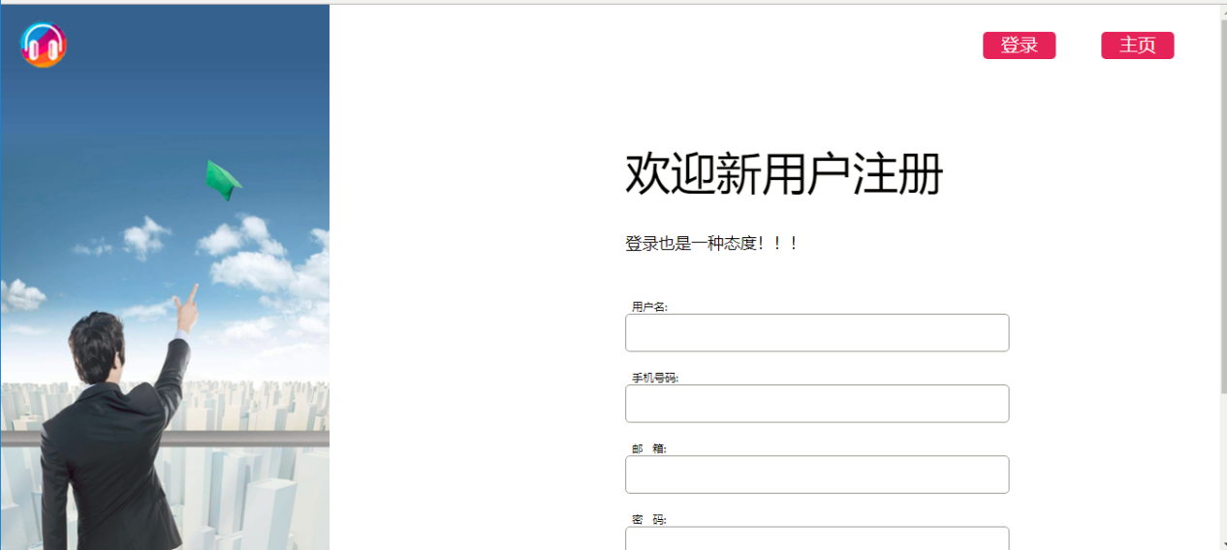

代码：

using System;

using System.Collections.Generic;

using System.Linq;

using System.Web;

using System.Web.UI;

using System.Web.UI.WebControls;

using System.Data;

using System.Data.SqlClient;

using System.Configuration;

public partial class register : System.Web.UI.Page

{

public static string connstr = ConfigurationManager.ConnectionStrings["newsConnectionString"].ConnectionString;

SqlConnection conn = new SqlConnection(connstr);

protected void Page_Load(object sender, EventArgs e)

{

}

protected void btnregister_Click(object sender, EventArgs e)

{

try

{

conn.Open();

string str = "select * from users where username='" + txtusername.Text + "' ";

SqlCommand cmd = new SqlCommand(str, conn);

SqlDataReader reader = cmd.ExecuteReader();

if (reader.HasRows)

{

Response.Write("<script>alert('用户名已被占用，请重新输入新用户名!')</script>");

reader.Close();

}

else

{

reader.Close();

string str1 = "insert into users(username,phone,email,password,sex) values('" + txtusername.Text + "','" + txtphone.Text + "','" + txtemail.Text + "','" + txtpassword.Text + "','" + RadioButtonList1.SelectedValue + "')";

SqlCommand cmd1 = new SqlCommand(str1, conn);

cmd1.ExecuteNonQuery();//因为插入语句没有最后的结果集需要存储

// Response.Write("<script>alert('注册成功!')</script>");

Session["username"] = txtusername.Text;

Response.Redirect("Default.aspx");

}

}

catch

{

Response.Write("<script>alert('注册失败!')</script>");

}

finally { conn.Close(); }

}

protected void btncancle_Click(object sender, EventArgs e)

{

txtusername.Text = "";

txtpassword.Text = "";

txtrepassword.Text = "";

txtemail.Text = "";

txtphone.Text = "";

//Response.Redirect("~/AdminDefault.aspx");

}

}

### 其它隐藏登录界面

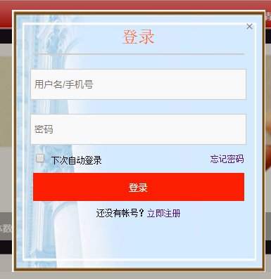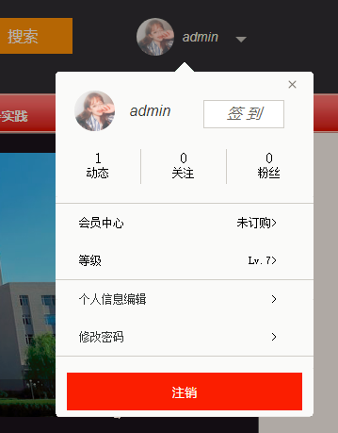

代码

using System;

using System.Collections.Generic;

using System.Linq;

using System.Web;

using System.Web.UI;

using System.Web.UI.WebControls;

using System.Data;

using System.Data.SqlClient;

using System.Configuration;

public partial class MasterPage : System.Web.UI.MasterPage

{

public static String conString = ConfigurationManager.ConnectionStrings["newsConnectionString"].ToString();

private SqlConnection con = new SqlConnection(conString);

protected void Page_Load(object sender, EventArgs e)

{

if (Session["username"] == null)

{

Labeluser.Text = "未登录";

Image1.ImageUrl = ResolveUrl(SelectHeader());

}

else

{

Labeluser.Text = Session["username"].ToString();

Image1.ImageUrl = ResolveUrl(SelectHeader());

Image2.ImageUrl = ResolveUrl(SelectHeader());

Label1.Text = Session["username"].ToString();

}

}

public string SelectHeader()

{

string s = "images/user000.jpg";

string sql = "select picture from users where username = '" + Labeluser.Text + "'";

con.Open();

try

{

SqlCommand com = new SqlCommand(sql, con);

SqlDataReader re = com.ExecuteReader();

if (re.Read())

s = re.GetString(0);

else

s = "images/user000.jpg";

re.Close();

return s;

}

catch (Exception ex)

{

return s;

}

finally

{

con.Close();

}

}

//获取配置连接信息

public static string connstr = ConfigurationManager.ConnectionStrings["newsConnectionString"].ConnectionString;

//建立连接对象 ，将配置信息作为 连接对象的参数

SqlConnection conn = new SqlConnection(connstr);

protected void btnlogin_Click(object sender, EventArgs e)

{

try

{

//写对数据库的操作语句

string str = "select * from users where username='" + txtmanagename.Text + "' and password='" + txtmanagepassword.Text + "'";

//打开数据库连接；

conn.Open();

//建立一个对数据库的操作的执行对象命令

SqlCommand cmd = new SqlCommand(str, conn);

//执行对数据库的操作，并将对数据库操作的结果保存起来

SqlDataReader reader = cmd.ExecuteReader();

//对结果进行判断并处理

if (reader.HasRows)

{

Session["username"] = txtmanagename.Text;

Session["password"] = txtmanagepassword.Text;

// Response.Write("<script>alert('登录成功!')</script>");

Response.Redirect("Default.aspx");

}

else

Response.Write("<script>alert('用户名或密码错误，登录不成功')</script>");

reader.Close();

}

catch

{

Response.Write("<script>alert('用户名或密码错误，登录失败')</script>");

}

# //关闭数据集，关闭连接

finally

{

conn.Close();

}

}

protected void lbtnexit_Click(object sender, EventArgs e)

{

Session.Abandon();//注销会话期

Labeluser.Text = "未登录";

Image1.ImageUrl = ResolveUrl(SelectHeader());

}

protected void btnsearch_Click(object sender, EventArgs e)

{

if (DropDownList1.SelectedValue == "all")

Response.Redirect("~/search.aspx?all=" + txtsearch.Text);

else

Response.Redirect("~/search.aspx?"+DropDownList1.SelectedValue+"=" + txtsearch.Text);

}

}

### 后台登录

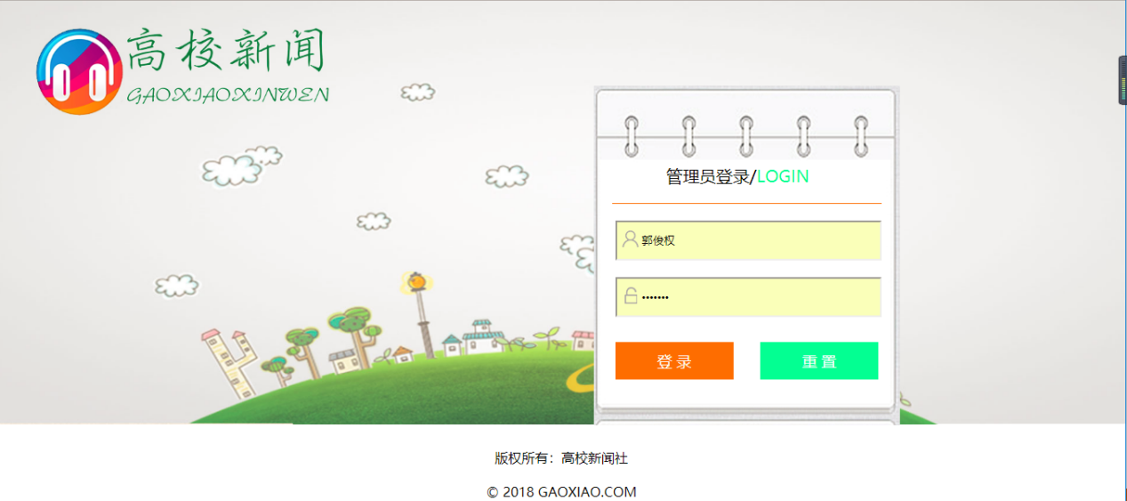

代码：

using System;

using System.Collections.Generic;

using System.Linq;

using System.Web;

using System.Web.UI;

using System.Web.UI.WebControls;

using System.Data;

using System.Data.SqlClient;

using System.Configuration;

public partial class login : System.Web.UI.Page

{

//获取配置连接信息

public static string connstr = ConfigurationManager.ConnectionStrings["newsConnectionString"].ConnectionString;

//建立连接对象 ，将配置信息作为 连接对象的参数

SqlConnection conn = new SqlConnection(connstr);

protected void Page_Load(object sender, EventArgs e)

{

}

protected void btnlogin_Click(object sender, EventArgs e)

{

try

{

//写对数据库的操作语句

string str = "select * from manage where managename='" + txtmanagename.Text + "' and managepassword='" + txtmanagepassword.Text + "'";

//打开数据库连接；

conn.Open();

//建立一个对数据库的操作的执行对象命令

SqlCommand cmd = new SqlCommand(str, conn);

//执行对数据库的操作，并将对数据库操作的结果保存起来

SqlDataReader reader = cmd.ExecuteReader();

//对结果进行判断并处理

if (reader.HasRows)

{

Session["managename"] = txtmanagename.Text;

Session["managepassword"] = txtmanagepassword.Text;

// Response.Write("<script>alert('登录成功!')</script>");

Response.Redirect("~/HouTai/AdminDefault.aspx");

}

else

Response.Write("<script>alert('用户名或密码错误，登录不成功')</script>");

reader.Close();

}

catch

{

Response.Write("<script>alert('用户名或密码错误，登录失败')</script>");

}

//关闭数据集，关闭连接

finally

{

conn.Close();

}

}

/*重置按钮事件**/

protected void btncancle_Click(object sender, EventArgs e)

{

txtmanagename.Text = "";

txtmanagepassword.Text = "";

}

}

## 五、数据库说明

### 1、版本说明

VS：Visual Studio 2012

SQL：SQL Server Management Studio2008 2R

浏览器：火狐，谷歌

### 数据库表字段及数据说明

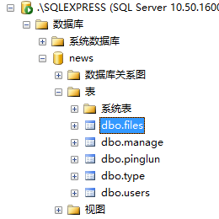

表：files

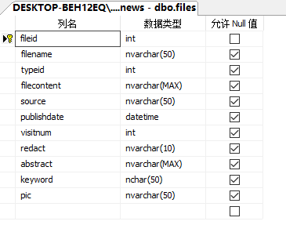

数据：

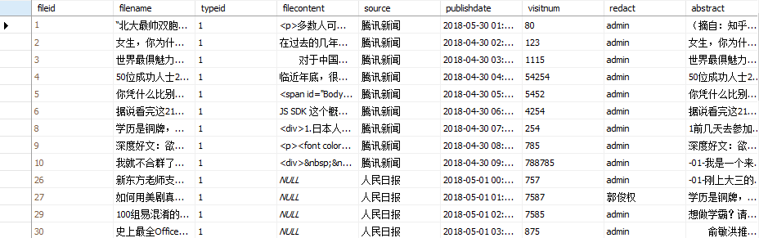

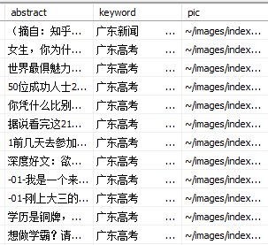

表：manage

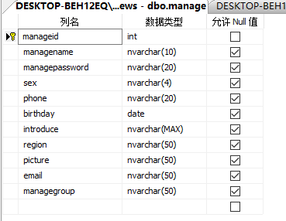

数据：

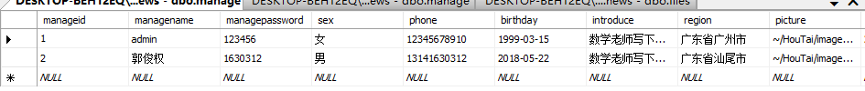

表：user

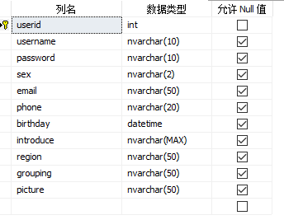

数据：

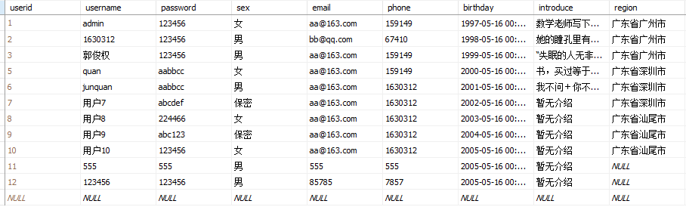

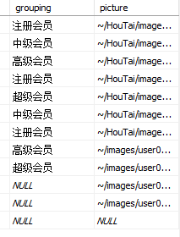

表：pinglun

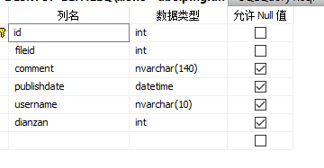

数据

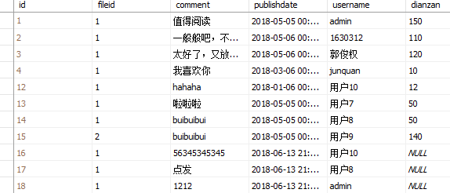

表：type

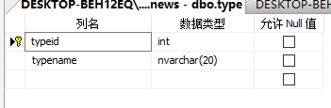

数据

